**Grey Paper**

**Group Members: Abdul Wahab, Umme Habiba, Haniya Ghauri**

1. HTML code for the navigation menu on top. It has four menu options that lead to their own separate pages on the website

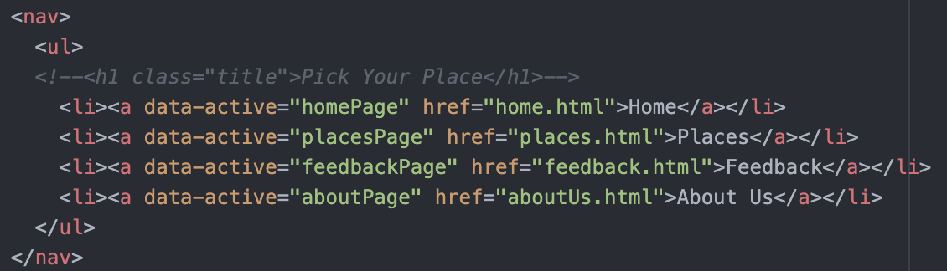

1. HTML code for a div that contains three popular places of the week on the homepage



1. The animation for the hover effect on the nav options on each page. This gives a yellow underline effect on the option that is hovered

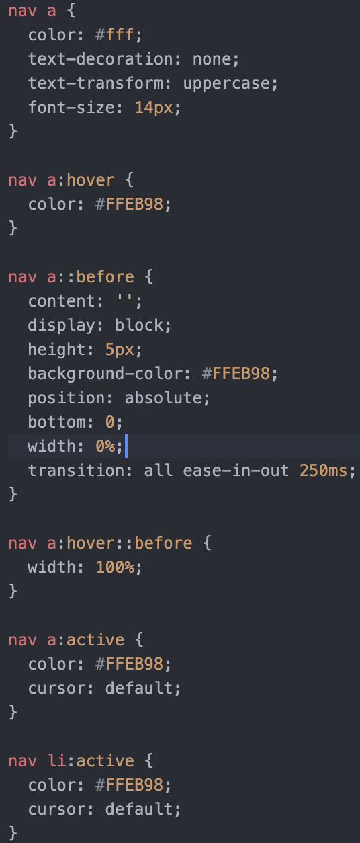

1. HTML code for the center image (banner) that is on the homepage. It is a banner that has a tagline for our website.

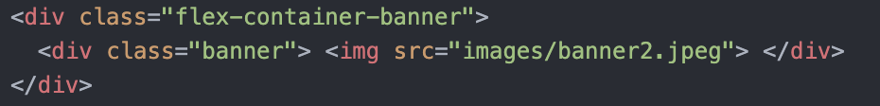

1. This is the CSS code how the yellow lines are styled for all headings, they vary on size based on the length of the heading

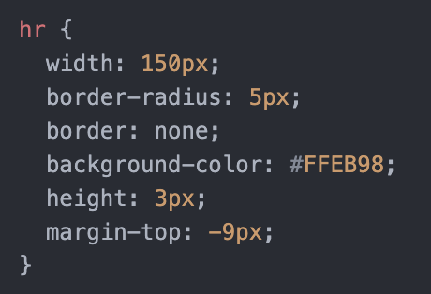

1. CSS code for how the images are displayed and styled. There are three images on homepage that are centered and have a fixed size and added radius

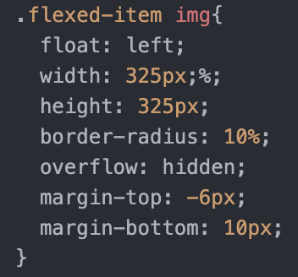

1. Below is the HTML code for the bucket list on the homepage. This idea was from the udemy course and it adds locations to your list that you can cross off or delete

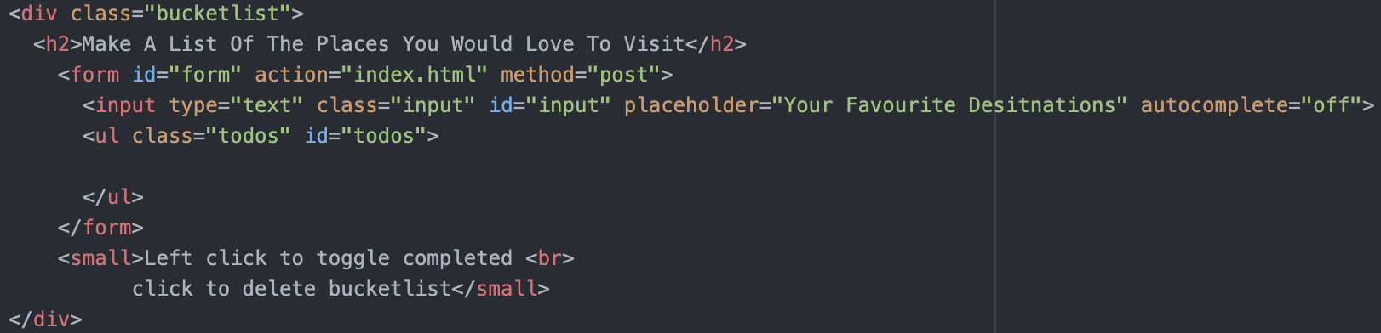

1. CSS code for how the items in the bucket list are made to look crossed out and how they are displayed when added

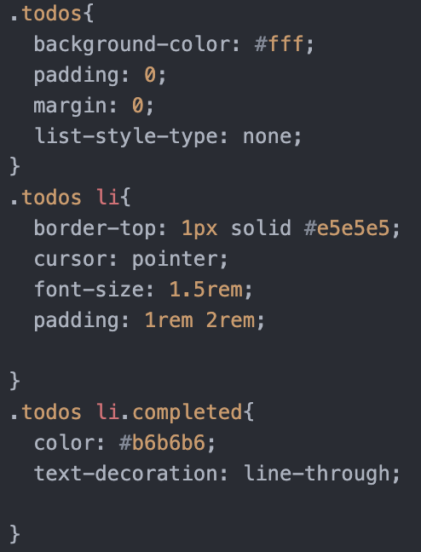

1. This is the html code for displaying the categories on the “places” page. It is in 2 divs and each div contains 3 sub divs as each place

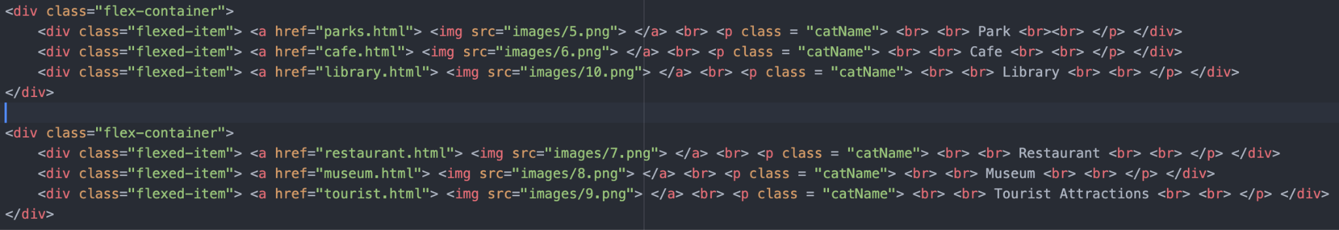

1. Below is the css code for how the titles of each of the categories in the places page is styled. It has a dark background that is styled to look like its under the image/icon card

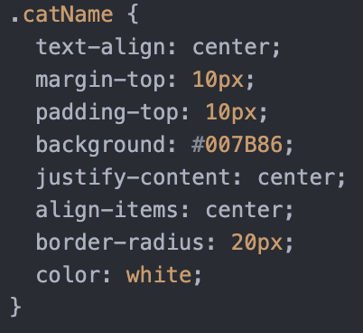

1. This is the code for the container that holds the 2 rows of categories. It is styled to center and its flex direction is row because that's how the category cards are laid out on the website

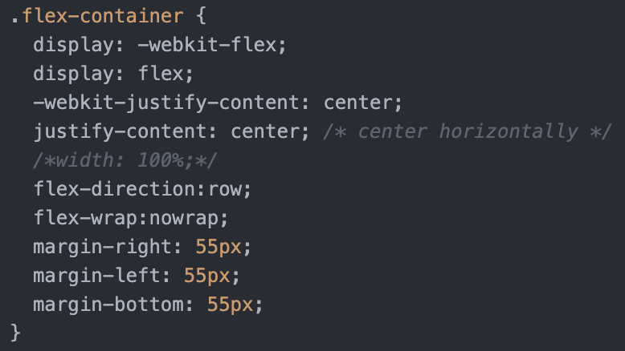

1. HTML code for the title and some main highlights of the place in a specific category (in this example its a cafe)

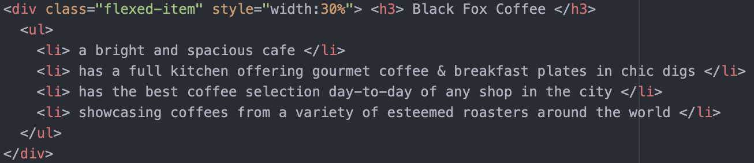

1. This is the html code for the rightmost column of the section on each location page. It displays address, ratings for the place and a button that leads to the feedback page

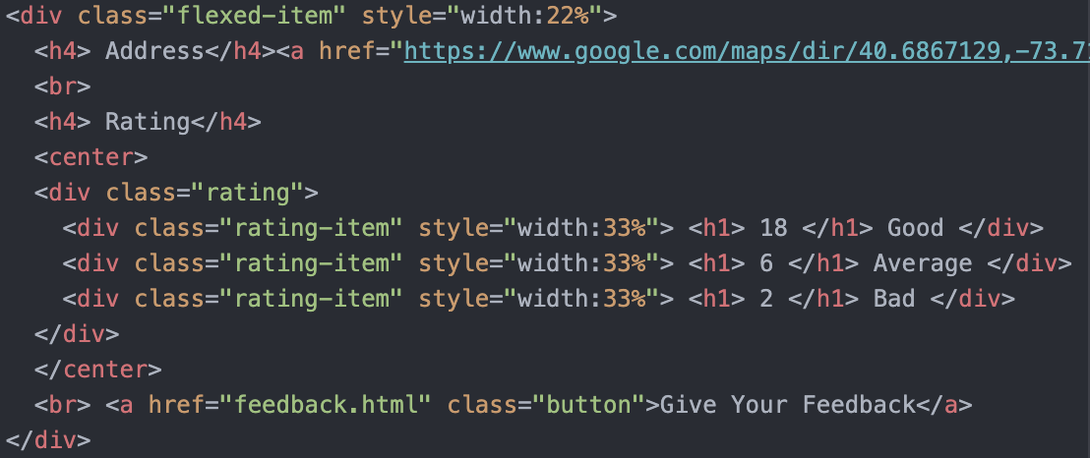

1. Below is the css code for styling the feedback button so it has 2 states, default which is a green color with yellow border and hover state that turns the button yellow

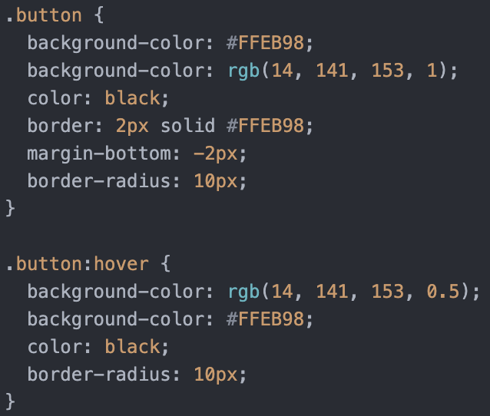

1. This css code shows how the ratings are styled. It has one row and three columns for good, average, bad and each have title and numbers.

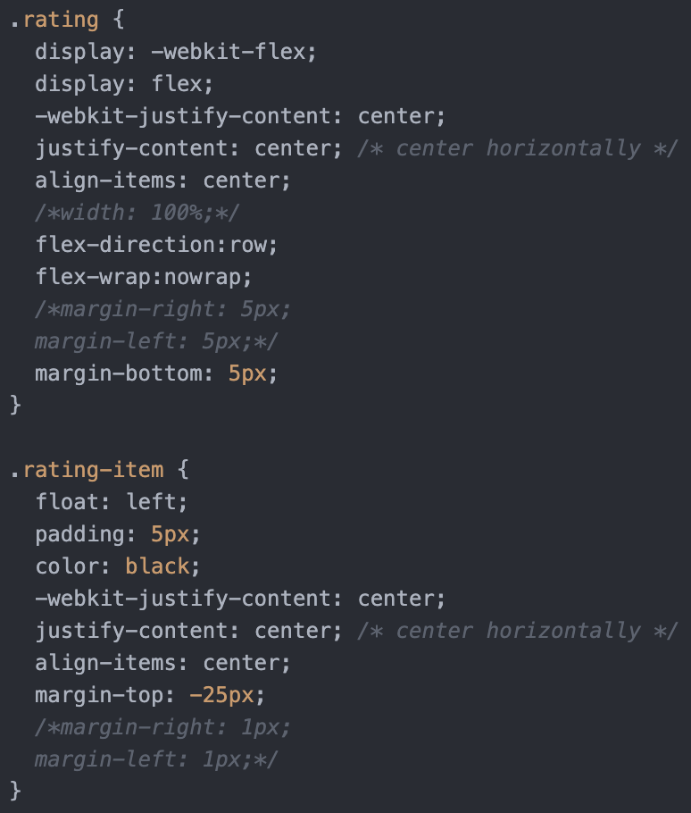

1. The following code shows the styling that is added to the title of the page for each location

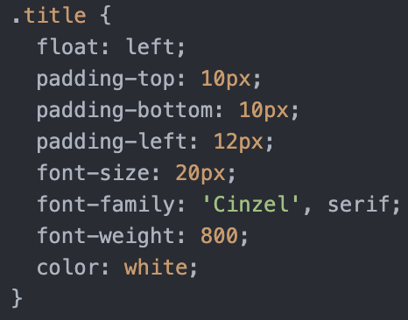

1. HTML code for the form on the feedback page. This part of the code is getting text input from user such as their first and last name and name of the location they want to give feedback for

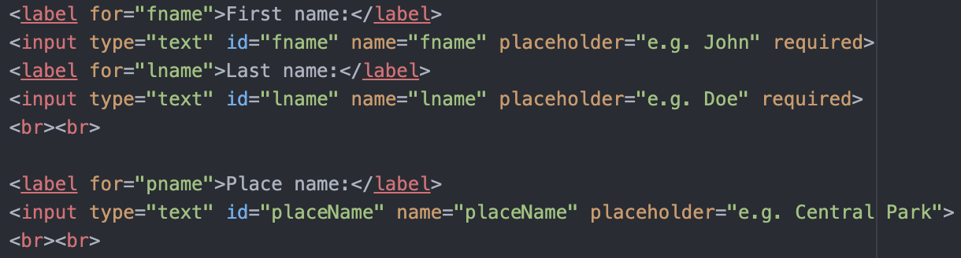

1. This code asks for the user's experience given the 3 emojis that are clickable (good/satisfied, average, bad/unsatisfied). This idea was also from udemy projects..\

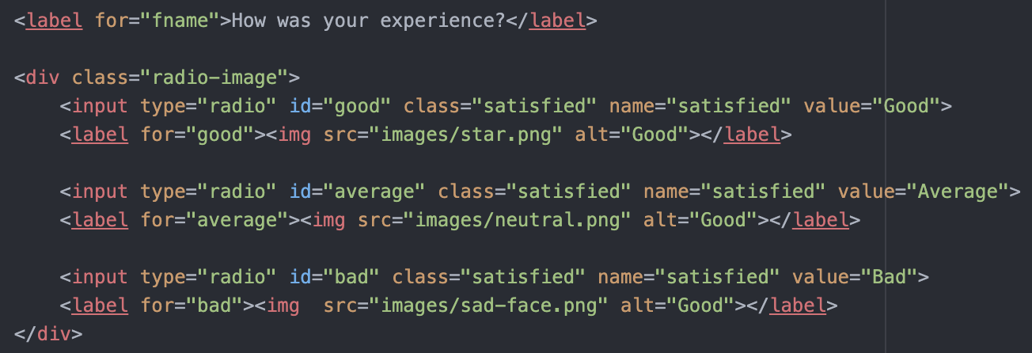

1. This is html code that further asks for the experience in a different way. The user is asked to give a rating out of 10 using a scale they can drag. This is another idea from udemy projects. Got stuck in updating the label everytime the cursor moved but then used javascript to implement this.

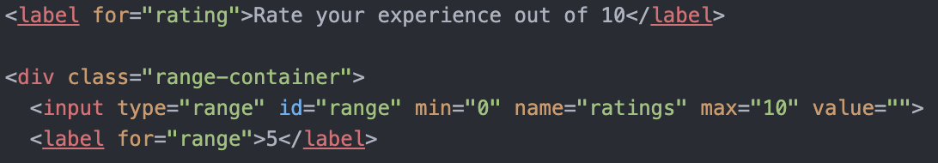

1. The following code is for a text box that is draggable and users can explain here their experience in words. It also has a submit button (code will be discussed later)

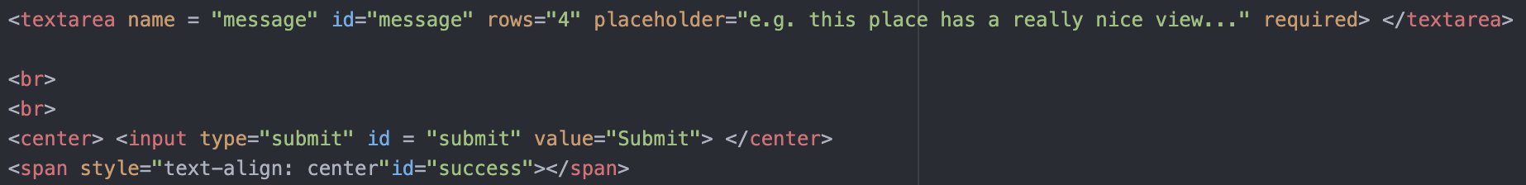

1. CSS code for how the two sections on about us page are styled (who we are and what we do)

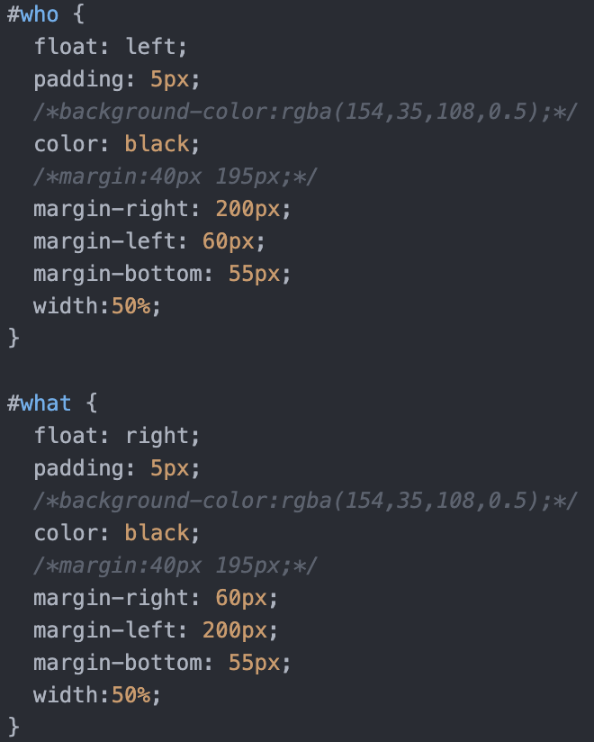

1. JavaScript code to connect our to a google sheets file where all feedback responses are saved.



1. The following is a javascript snipped for when the feedback is submitted on the feedback page. On success it adds it to the google sheets displays a success message. On failure it displays a message on console. Got stuck in submitting this request. Had some issues in the code but was able to eventually fix it.

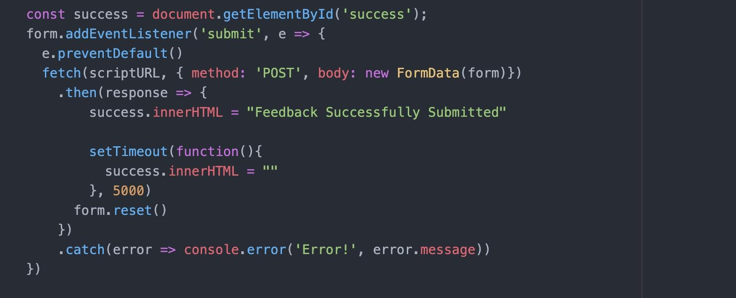

1. Javascript code for the range slider. We used a udemy course to get idea for this feature. Users can choose from 1 to 10 for their feedback.

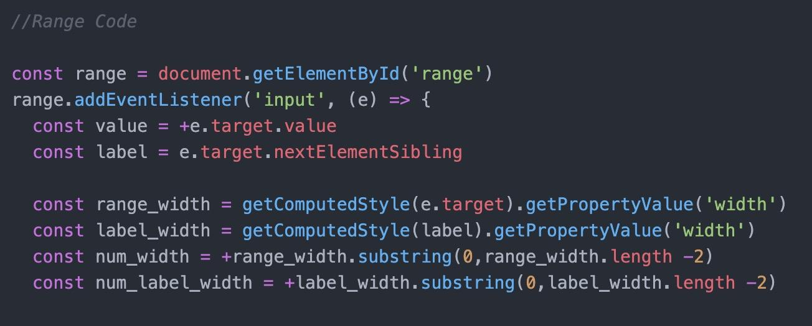

1. Javascript code for travel bucketlist on the home page. Users can add their top destinations and create a list for it. This code makes a new li tag and adds a new destination. It also has the remove features. Got stuck on how to remove the item from the list. But then came up with the idea to do right click to remove.

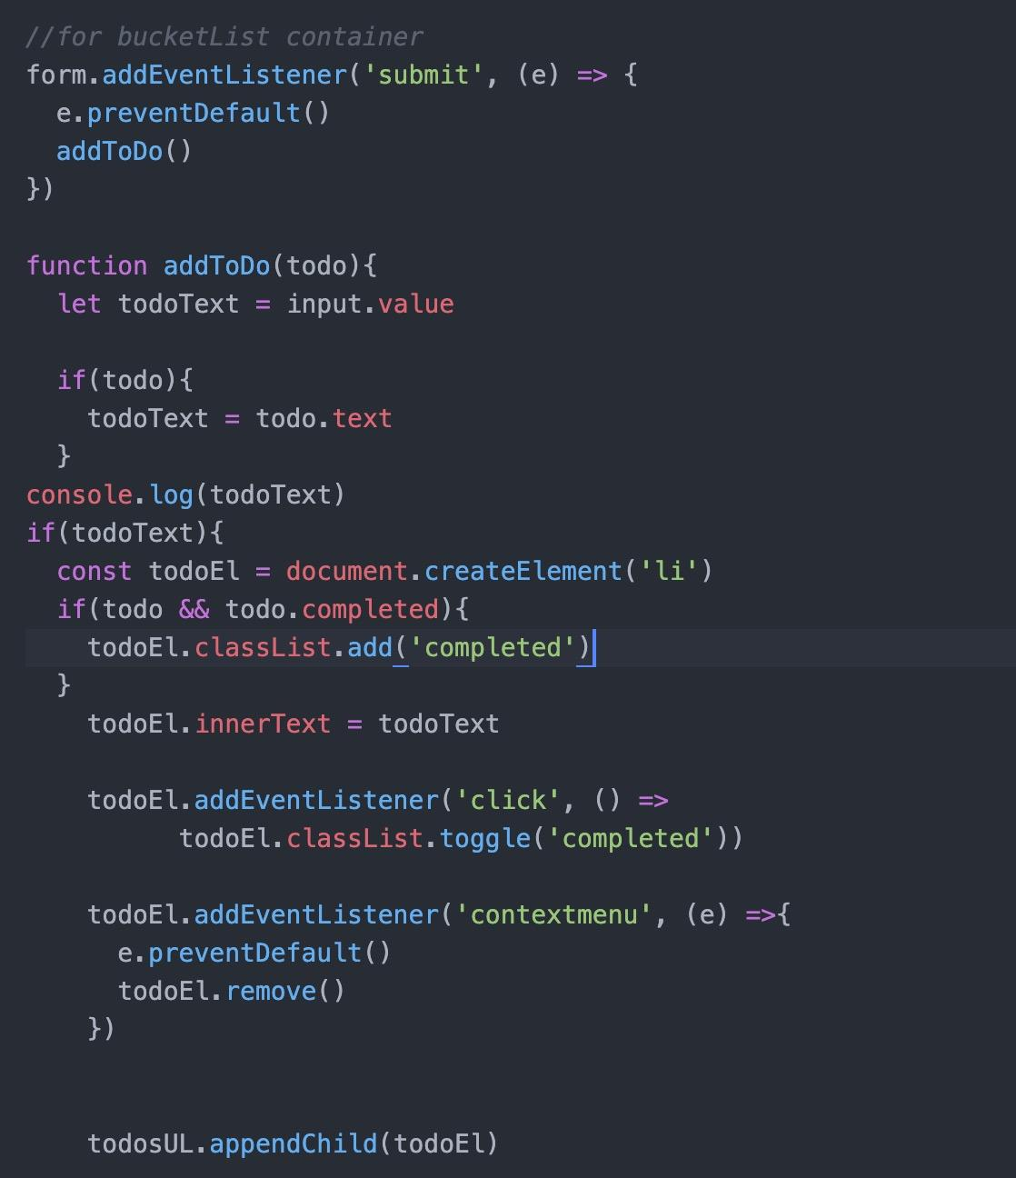

1. Javascript code for the random image generator on home page. Random images are retrieved from unsplash website and added here.

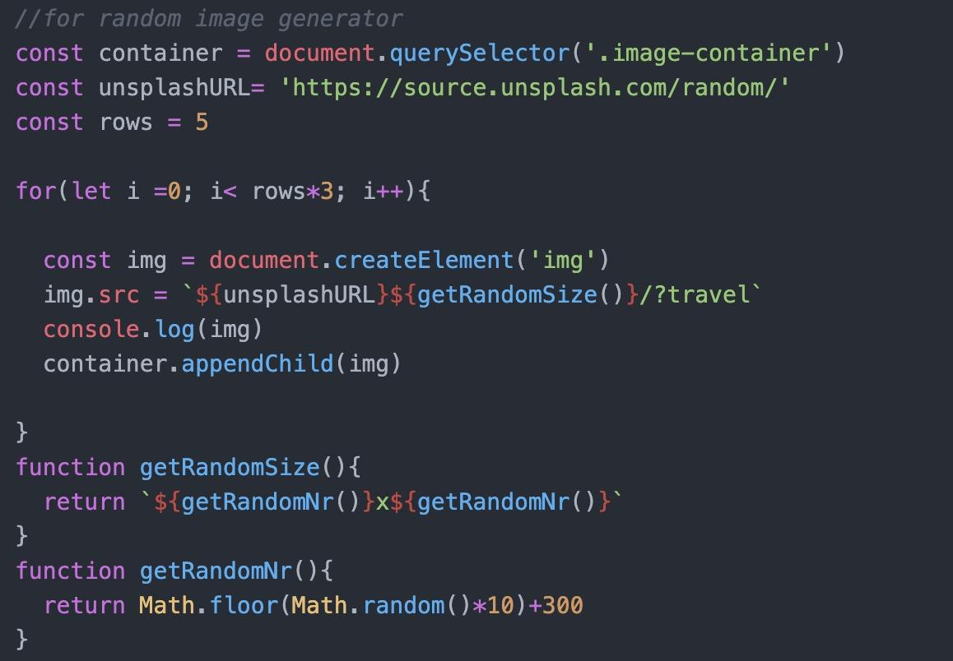

1. Javascript code that has been added to all pages of the project. It provides links to each tab on the website.

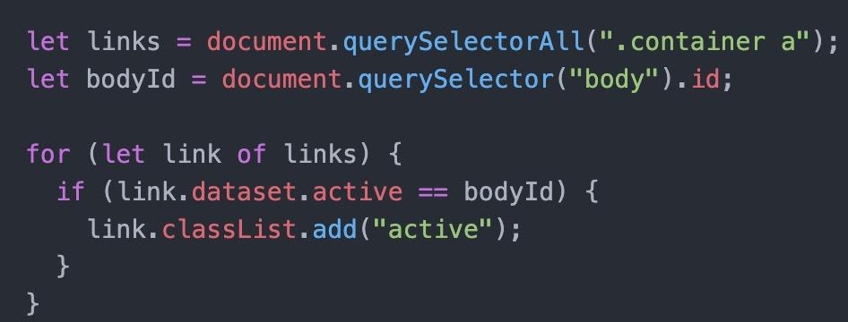

1. This is the snippet of the node javascript. It allows node server to open and run different types of files such as png, jpeg, html, js, json, etc. At first the team got stuck on rendering other types of files besides html such png, jpeg but then used some youtube ideas to implement this simple solution.

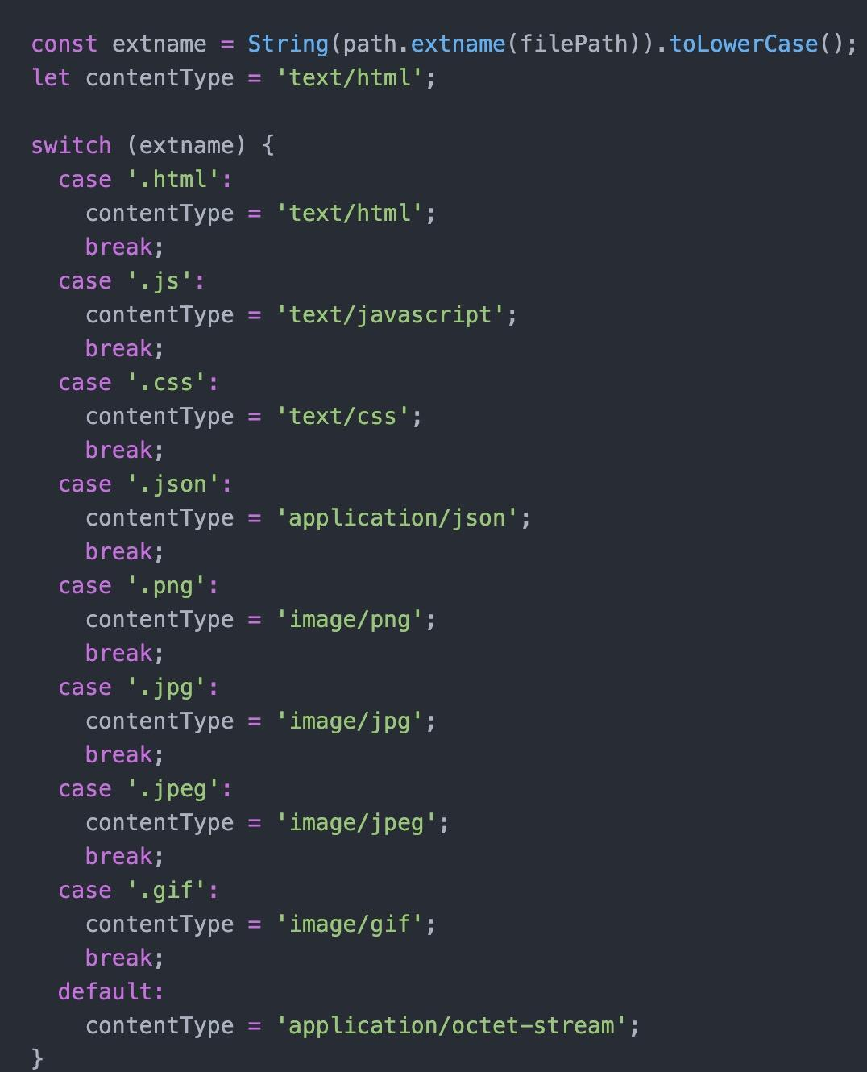

1. Javascript code for the node file.

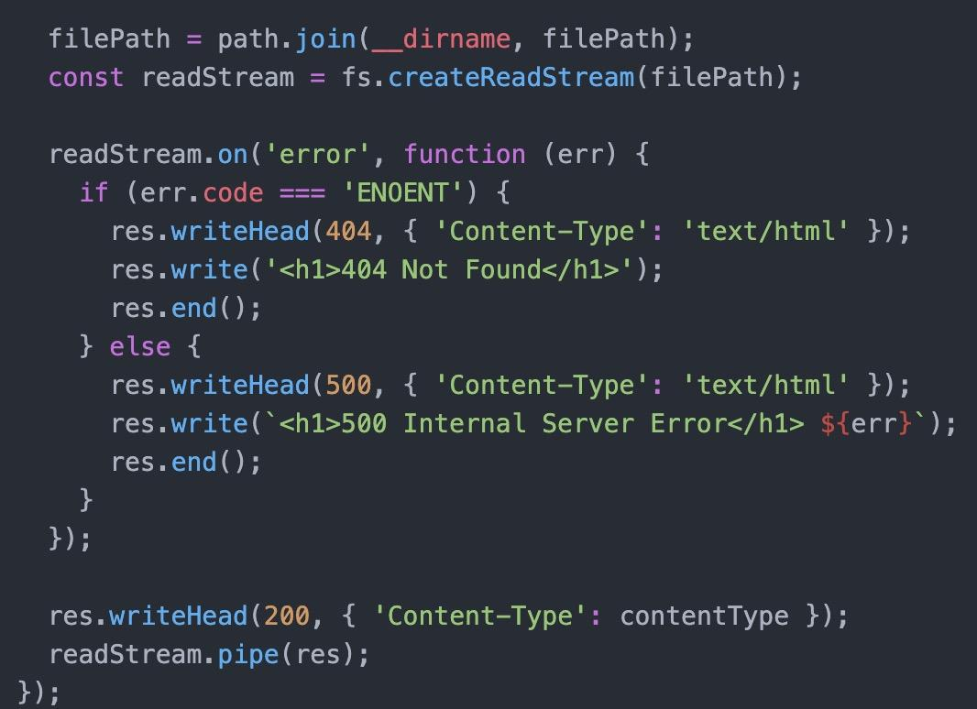

1. Javascript code to set the node which is 3000

